LED Display Receiving card HD-R501

For Sending card HD-A601/602/603/HD-A30/A30+ series

Parameter： 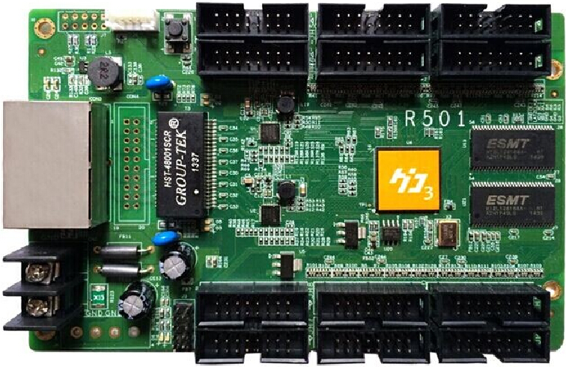
Type | Indoor & outdoor full-color & single/dual color module
Scan mode | Static, 1-32 scan randomly
1pcs of receiving card support areas | 256W*192H(suggest).  largest ：1024W×192H (single-dual color)
Receiving cards  connected ways | Receiving card set sequence randomly, it could recognize by automatically or by hand
Gray scale | 0-65536
Smart set | Smart set by few simple steps, through display routine setting ,it could suit almost different PCB routine
Play contents | Play video、animation、picture、text、excel、PPT、time、counter etc
Test functions | It have self test button, could test modes of red、green、blue、white、gray、oblique line、grid、spots etc
Time on/time off | Time on /off display by defined and time on/off display by computer
Port | 2pin 5V Power x1,1000M Ethernet portX2，75B HUB portx12
Voltage | 3V-6V
Working temperature | -30℃-85℃

